FYS3150: Computational Physics

SOLVING THE SCHROEDINGER'S EQUATION FOR
ELECTRONS IN A THREE-DIMENSIONAL HARMONIC
OSCILLATOR WELL

Authors
Moonis Ali Khalid
Teacher
Morten Hjorth-Jensen
Abstract
The goal of this project was to solve Schrodinger's equation to find the wave function of a system composed
by an electron in a harmonic oscillator well. The task was written as an eigenvalue problem, so the
implementation needed to solve the equation turned out to be the Jacobi method to diagonalize a matrix containing the discretization of the equation at different integration points.
Once the matrix was written in a diagonal form. I simply had to look at the lowest (ground state) eigenstates and the relative eigenvectors, which gave the energy of the particle and the wave function respectively.
The second part of the project consisted in a similar problem, except that two interacting electrons were to
be considered inside the harmonic oscillator potential. By rewriting Schrodinger's equation in terms of the
center of mass coordinate and relative coordinate I separated it and scaled and discretized the r-dependent Schrodinger equation to solve for eigenvalues and eigenvectors. Small changes were need for the potential.
On the programming side, the goal of the project was to implement Jacobi’s rotation method to diagonalize a tridiagonal Toeplitz matrix and find the eigen-values and vectors. And find an optimal value of rho that gives the best (closest to exact values) solutions to the eigenvalue problems. I also had to develop some reproducible tests and benchmarks for our algorithm, to show that it is working properly.
Contents
1. Introduction 2
2. Theory 2
3. Method 5
4. Results and Discussion 7
5. Conclusion 10
6. References 11

30. September, 2020

- Introduction
The goal of this project was to solve Schrodinger’s equation to find the wave function of a system composed by an electron in a harmonic oscillator well. This problem also could be written as an eigenvalue problem.
I have developed my own code for solving eigenvalue problems. I order to solve this problem I had to diagonalize a matrix containing the scaling of equation at different integration points. The matrix to diagonalize was a so-called tridiagonal Toeplitz matrix. This matrix has analytical eigenpairs (eigenvalues and eigenvectors) and was an excellent testing ground for my algorithms. I had to develop an eigenvalue solver based on Jacobi’s method.
The second part of this project was to consider two electrons, instead of one, inside the harmonic oscillator well. I had to rewrite the Schrodinger’s equation in terms of the center of mass and study the role of the repulsive Coulomb interaction, and it turned out that very few changes were needed to the previous problem, to solve this one.
- Theory
The first eigenvalue problem we will be working with is a classical mechanics problem; a buckling beam. The vertical displacement of the beam in the y-direction, u(x) is given by the following differential equation:
(2.1)
Where is a constant defined by properties, like the rigidity(hardness) of the beam and F is the force applied at (L, 0) towards the origin. We solve this equation with Dirichlet boundary conditions: u(0) = u(L) = 0.
We want to scale the equation to be able to work with reasonable numbers. We assume that the values for , F and L are known, and define the dimensionless variable:
(2.2)
where p is in [0,1]. This gives dx => L dp, which means that Eq. (2.1) can be rewritten as the dimensionless equation
(2.3)
Where . This becomes our new dimensionless eigenvalue problem and it can be solved numerically by discretizing. I will Discretize this in the Discretization section and give a brief Introduction/explanation of what Discretization is.
From quantum mechanics we have the Time-Independent Schrödinger’s equation of the form
(2.4)
If the Hamiltonian is independent of time this is separable, and the left side of (2.1) is taken as E, and we get the time-independent Schrödinger equation;
(2.5)
For a single electron the Hamiltonian has the form
(2.6)
Or if written in the function basis,
(2.7)
Writing out (2.10) in spherical coordinates we end up with the equation
(2.8)
Now we look at electron(s) in harmonic oscillator potential:
(2.9)
This potential is spherical symmetric, and hence the Schrodinger equation is separable:
(2.10)
After separation, the radial part of the equation is:
(2.11)
where r is in [0, ].
The energies(eigenvalues) of the 3-dimensional harmonic oscillator are:
(2.12)
with n =0,1,2,… and =0,1,2,… .
We want the radial Schrodinger equation to be rewritten as an eigenvalue equation including the double derivative. Because of that we define u(r) = rR(r), which gives us:
(2.13)
If we want the wave function to be finite, when r=0, and go to zero, when r approaches infinity, which means a normalizable wave function, then the boundary conditions have to be u(0) =u()=0.
Now to scale the equation, we define a dimensionless variable p=r/, where has a unit length. Our equation then becomes:
(2.14)
Where we have chosen =0 in this project, which, in terms of our p, gives us our harmonic oscillator potential to be:

Inserting this in Eq. (2.17), we get:
(2.15)
We still have a unit energy/length(squared) in the coefficients of this equation, so we scale this equation by dividing it by , which gives us:
(2.16)
Now we can fix the constant
(2.17)
Thus, we can rewrite the Schrodinger equation as an eigenvalue equation:
(2.18)
Where I have set .
This equation can now be discretized and solved as a linear system with Jacobi’s algorithm for eigenvalues and eigenvectors. I will show the discretization and talk about my Jacobi’s algorithm in Method.
Now we will talk about Two electrons in the 3D Harmonic Oscillator. With two electrons in the same potential, a repulse Coulomb interaction will emerge between them, and the potential will become:
(2.19)
Where r is the relative coordinate . If we consider no repulse Coulomb Interaction, we have the following Schrodinger Equation in Spherical coordinates:
(2.20)
Where we have done some simplifications as for the one particle system, like setting.
The Schrodinger equation with Coulomb interaction reads:
(2.21)
The full energy of the system is given by . Where is the two-electron energy and is the energy in terms of the center-of-mass coordinate R = . The Radial Schrodinger equation with the center of mass coordinates for two electrons is:
(2.22)
What we have in Eq. (2.24) is a one-dimensional, r-dependent Schrodinger equation which we can solve numerically after scaling and discretizing.
We begin by scaling the equation. We define and divide , and this gives us:
(2.23)
To simplify the equation further, we can define:
(2.24)
and fix by requiring
(2.25)
By doing so, our equation reads:
(2.26)
Where I have set .
Now we have a scaled equation that we will discretize in the discretization section.

- Method
Discretization:
Discretization is the process through which we can transform continuous variables, models or functions into a discrete form. We do this by creating a set of contiguous intervals (or bins) that go across the range of our desired variable/model/function [2].

We use a standard center approximation for the second derivative of u:
(3.1)
Where h is our step length.
For a finite value of , we define h as:
(3.2)
and for

Let’s start by discretizing Eq. (2.3), following these discretization methods. By doing that we get:
(3.3)
Where h is the step length, in this case h = 1/n+1 because L is in {0,1,2, …. ,n,n+1}. We can rewrite this as a set of linear equations, which can be written as a matrix eigenvalue problem of a tridiagonal Toeplitz matrix.
(3.4)
The endpoints ( and ) are left out as they are set to zero by boundary conditions. In our case and, but in general this tridiagonal Toeplitz matrix has analytical eigenpairs, with eigenvalues
(3.5)
Thus, I implement Jacobi’s method and test my results against the analytical eigenvalues given by Eq. (2.12) by writing a unit test. I also find out and study the number of iterations needed to diagonalize the, said, matrix as a function of the matrix size n by implementing an iteration counter.
For one electron in the 3D Harmonic oscillator we got a scaled Eq. (2.18), which we discretize and get:
(3.6)
And the by defining and we get:
(3.7)
This corresponds to the same matrix eigenvalue problem as in Eq. (3.4), and we will solve it by Jacobi's method to obtain both the eigenvalues and eigenstates of one electron in a harmonic oscillator potential.
The analytical eigenvalues are in this case given by Eq. (2.12) and definition in Eq. (2.18), which together give When working with the harmonic oscillator potential
we need to define a maximum value of , as is not applicable numerically.
To find the ideal value of we calculate the first three eigenvalues and compute their difference with the analytical ones. We do this for different values of both n and and compute the average deviation for each and n. This way we can find the optimal combination of n and .
Now we discretize the scaled Eq (2.26) and get:
(3.8)
And the by defining and we get:
(3.9)
Yes, this is the same set of linear equations as in Eq. (3.7), that what discretization do. Now we can solve this discretized equation by Jacobi’s method and find both the eigenvalues and eigenvectors of the r_dependent Schrodinger equation for two interacting electrons in a 3D Harmonic oscillator potential.

Jacobi’s Method; Jacobi’s rotation algorithm:
We use Jacobi's method to diagonalize our matrix in order to be able to find the eigenvalues of the matrix. This method consists of several successive rotations in various hyperplanes, where in each rotation we zero out two off-diagonal elements.
To obtain the eigenvalues of our matrix we are going to apply similarity transformations to, so that
, (3.10)
by using an orthogonal transformation matrix:

With
To make this process effective we find the largest non-diagonal element, say and choose an angle of rotation so that the ij-element of the transformed matrix becomes zero.
(3.11)
This equation can be rewritten, by dividing all terms by which gives
(3.12)
Where and , and then by solving Eq.(3.12) for t we get:
(3.13)
Now we have to be smart and understand what the + and – roots mean, when it comes to numerical precision. To avoid loss of numerical precision by subtracting two almost equal numbers, we can do the following:
(3.14)
(3.15)
Now we can set and and from the equation above we can get the following relation for c and t:
(3.16)
And the we can easily see that s and c relation gives .
Now we take a look at how the matrix elements change when we multiply A by S and then the transformed S () from the left. So, let’s look at :
(3.17)
(3.18)
This only changes the rows i and j.
When we multiply the resulting matrix with S from the right, this only affects the columns i and j and changes them to:
(3.19)
(3.20)
So that means we continue doing the transformation until max squared value of a non-diagonal element of A is smaller then or equal to a very small value, let’s call it epsilon(our tolerance, which we have set to be ), for j<i. Then we can say that our matrix is diagonalized. And hence the Eq. (3.6), where we do N similarity transformations of A and get D. D is the diagonal matrix and its diagonal elements are the eigenvalues of A.

Let’s say that the eigenvectors of A are the columns of matrix x, let’s call them , then we know that we can find x by doing this:

, (3.21)
So, the eigenvectors correspond respectively to the eigenvalues that are the diagonal elements , of D.
- Results and Discussion
The unit test for the buckling beam ran successfully, which means that the implemented Jacobi's method returned the correct eigenvalues in Eq. (3.5) (up to a tolerance). In Fig. 1, we see how the number of iterations needed to diagonalize the matrix A by doing similarity transformations, depends on the size n of the matrix we're diagonalizing. The plot shown in the figure 1 has a slope of, almost, 2.02, which means that the number of iterations needed is . This figure was generated with a tolerance of epsilon = . The number of FLOPS for each iteration is (where i have counted the if-test for finding the closest value of to zero, as one flop). Since the number of FLOPS per iteration is , the total number of FLOPS then becomes . Because of this, Jacobi's method makes the upper bound for the matrix size very small compared to other methods. That’s why this method is not the right way to go when it comes to solving eigenvalue problems for large matrices.
Table 1: The first three energy eigenvalues for one electron in a 3d Harmonic oscillator potential compared with the analytical values. With = 4.65.
Eigenvalue num: | Numerical: | Analytical: | Matrix size n:
0 | 2.9992 | 3 | 90
1 | 6.9991 | 7 | 190
2 | 10.9990 | 11 | 200
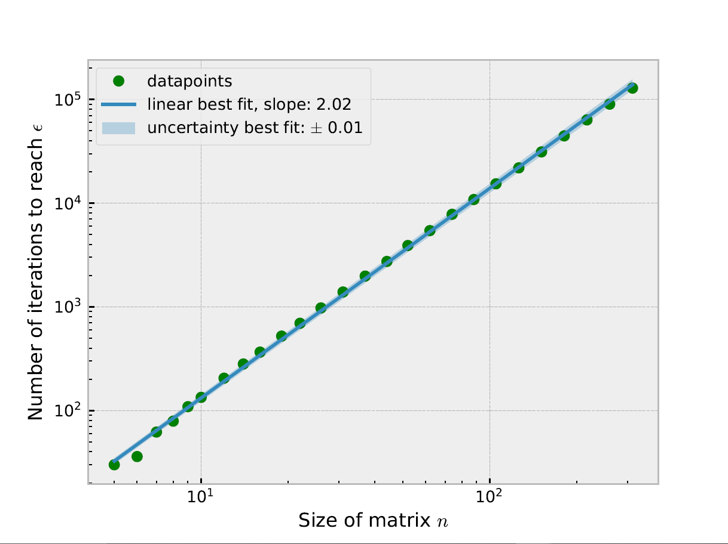
Figure 1: Iterations needed to diagonalize a matrix using Jacobi’s rotation method, here plotted as a function of matrix size n, with tolerance of epsilon= . So that the largest non-diagonal element is smaller than epsilon.

I found that the optimal value of is 4.65. The energies found for the single electron in a harmonic oscillator potential are given in table 1. The precision when calculating the energy eigenvalues depend on the size of the matrix. For the ground state it required a matrix size of 90 to reach a precision of four leading digits. The results are also shown in table 1.

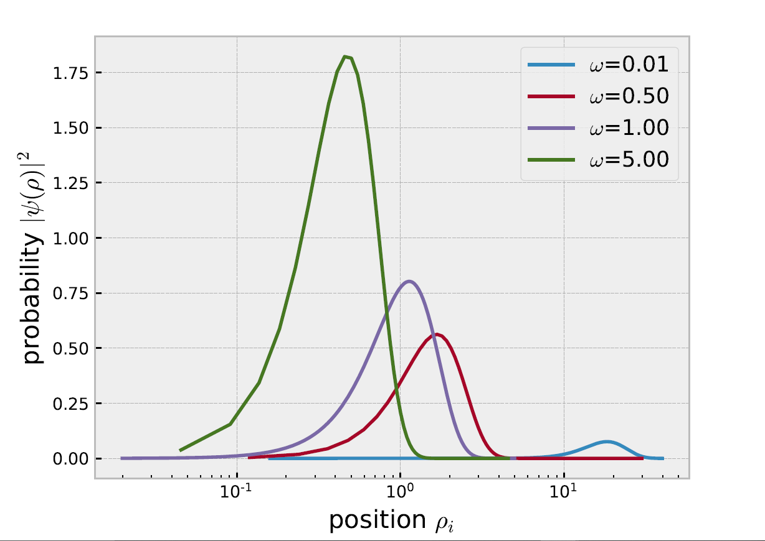
Figure 2. This graph represents the solution of the radial equation of the ground state of the two interacting electrons in a harmonic oscillator potential for different values of Where the values on y-axis are from the solution of the radial equation.

Table 2: Here we compare different ground state eigenvalues found by my Jacobi’s method, with different , with the analytical eigenvalues by M.Taut [4], with given .
: | : | Analytical: | Numerical:
0.25 | 10 | 1.25 | 1.24997
0.05 | 20 | 0.35 | 0.349997
0.01827 | 30 | 0.1644 | 0.164441

When we introduce a second electron in our system and study the ground state, with the quantum number i set to zero, we get the results shown in table 2. Due to the theoretical work of M. Taut [4] we can compare the numerically found ground state eigenvalue with the analytical one. The effect of the Coulomb interaction is shown in Fig. 3 on the next page where the ground state is shown for the single and two electron case, with = 1.0.

For finding the energy eigenvalue of the ground state, with four leading digits, we needed 270x270 matrix, which since the number of FLOPS is , takes a long time to calculate.
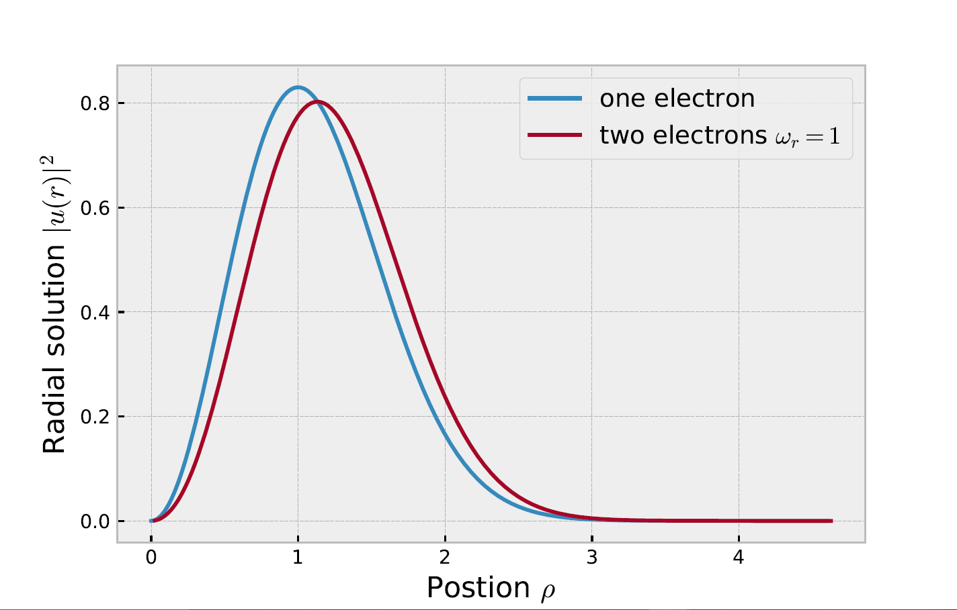
Figure 3: This graph represents the solution of the radial equation of the ground state of one electron and two interacting electrons in a 3d harmonic oscillator potential, with = 1.0, for the latter.

Jacobi's method limits the precision of our eigenpairs, due to the required computational time. For the one-electron case in a harmonic oscillator, I used the analytical eigenvalues to find an ideal value of .
In theory should be infinite, but this is not possible for a computer, so we must make a compromise. If we make too small the wavefunction will not converge to zero and if we make it too big, the precision of decreases. As you can see in table the ideal value of for the ground state energy eigenstate is 4.65 because this gave me the closest eigenvalue to the analytical one.

- Conclusion
In this article we studied eigenvalue and eigenvector problems numerically using Jacobi's method. We have studied three different physical problems; the buckling beam, quantum dots with one electron and with two electrons. The continuous equations were scaled and discretized and then converted into linear algebra equation. Solving this equation gave us the eigenvalues and eigenvectors of the system. Jacobi's method is an iterative method, which means that it will continue to run until a condition, set by the programmer, is satisfied. I found that the number of iterations needed to satisfy the condition increases with the size of the Matrix . I calculated that the number of FLOPS per iteration is . Which results in the total number of iterations for a general nxn matrix being approximately . Since we were only working with tridiagonal matrices it was less effective to use the Jacobi's method compared to other algorithms, since Jacobi's method works best for a general matrix that’s not that big. For the harmonic oscillator potential, we had to define an upper bound of our position vector. Choosing the optimal value of is essential to calculating the correct eigenvectors and eigenfunctions. Since our problems had analytical solutions, we could compare the analytical and numerical eigenvalues to find the optimal values of . By comparing our eigenvalue with the analytical solutions, we found that our numerical eigenvalue was correct, and by using the theoretical work by M. Taut [4] we found that our ground state eigenvalue was correct also in the case of two interacting electrons.
- References
[1] Morten Hjorth-Jensen. Computational physics, lecture
notes fall 2015. Department of Physics, University of Oslo,
page 217, 2015.
[2] Discretization introduction https://towardsdatascience.com/an-introduction-to-discretization-in-data-science-55ef8c9775a2
[3] My project 1 report: 1D Dirichlet Problem
[4] M. Taut. Two electrons in an external oscillator poten-
tial: Particular analytic solutions of a coulomb correlation
problem. Phys. Rev. A, 48:3561{3566, Nov 1993.
[5] https://github.com/moonnesa/FYS3150-2020/tree/master/Project2

